**History of Javascript:_**

* In 1993 released the first popular web browser named **Mosaic.**
* Because Mosaic was **accessible (izos”k dj.;k;ksX;) to non-technical people**.
* Mosaic was played main role in the rappid growt of world wide web.
* The lead developers of mosaic founded **nestcape carporation**
* **In 1994 :** the Netscape released more polished/more batter browser named: **nestcape navigator.**
* Nastcape navigator **quickly become most used**.
* During these years the webpage could only be static.
* There was not dynamic behavior to these pages.
* **In 1995:** Netscape **decide- to add scripting language** in browser/webpages.
* They do two important action to achieve above aim.
  + **Collaborating with sun micro system** to **embed java programing language**.
  + **Hiring “branden Eich”** to embed **scheme language**.

**What is Scheme Language?**

* Scheme programming language is a **dialect (iksVHkk’kk) language of the lips family** of programming language.
* Scheme was created **in 1970** by Guys **L.steel and Gerald Jayy Sussman**.

**What is Lips?**

* It is a family of programming language with long history which was **specified in 1960**.
* Lips was **second oldest high level programming language**.

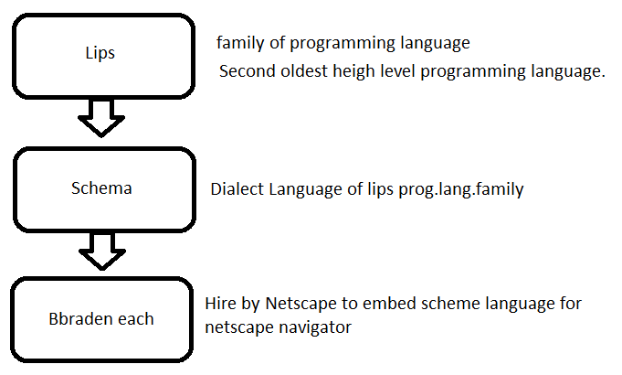

* Soon the management of Netscape decide a best option for Branden Eich
  + to create a new language.
  + Which syntax should be similar to java
  + Which syntax should be less than scheme and other extand () languages.
* This new language and its interpreter called **live script**.
* When this language created and send for the beta stage (beta:one stage of the life cycle released of any language ex. Pre alpha, alpha, beta, and the final stage before release is gold etc.
* **December 1995:** 
  + It was release time of this language for release and **name was changed from live script => javascript**
* Java script is trade mark of oracle corporation in the united states.
* Javascript trade mark transfer to the oracle acquired **sun micro system in 2009.**
* Javascript become so famous for we development so now every browser company was using same language with some changes and new name.
* It was the problematic event for the developers so **final it submitted to the ECMA international organization in 1997**.
* Now developer can use only one language and the website will response for every browser.
* Now the ES6 is latest version for use. It was second major revision to javascript publish in 2015.

**=============================**

**Examples of scripted behavior**

* Loading new webpage content without reloading the page, via ajax or a WebSocket.
  + Ex. We can send and receive massages without leaving the current page. Like fb massanger, whhataap and other chatting aap/webpages.
* Webpage animation, such as
  + Fading object in and out.
  + Resize and moving object.
* Playing browser games.
* Controlling the playback of streaming media.
* Generating pop-up ads or alert boxes.
* Web form validation before sending the data to web browser.
* Redirecting a user to another page.
* Storing and retrieving data on the users device via the strorage or IndexDB standard.

**==========================**

**Feature in javascript:**

* Imperative and structured: (**vko”;d vkf.k jpukRed**)
* Javascript supports much of the structrured programming syntax from c language
  + ex. If statement, while loop, switch statement, do while loop etc.
* Like C language javascript also make a distinction(**Hksn**) between expression and statements.

**Weakly/Dynamic typed language:**

* When we use let c = 1+’1’
* It gives the answer 11 by concatenation this behave we called weakly type.
* The behaviour of javascript which get the data type automatically it is also the example of weakly type language.
* When We don’t need to give the data type in the declearation of variable this behavior called Dynamic type feature of javascript.

**Object oriented**

* Object oriented means it is simple to use or understand.

**Variable**

* The variable is the name of memory location where we can store various type of data like number, string, and other
* Variable can be a thought of named container the you can store data in that container and then refer to the data simply by that name of container.
* *There are two part of variable*

1. Declaration=> var a;
2. Definition /initialization => a =10

* We can declear and define the variable in one line like: var a=10;

**\* What is var, let and const in the declearation of variable?**

***Var =***

* The var keyword is used in all javascript code from 1995 to 2015
* Let and const keyword were added in javascript in 2015.
* If we want to run our code in older browser you must use var.
* We use var to give the global scope to our variable.
* When we used var it makes our variable accessible in whole coding which we called global scope.
* We can redecleare and also reinitialize the variable when we decleare it with var keyword.
* It has default functional scope.

***Const:***

* When we decleare the variable with const keyword it works with general rules.
* It get block or functional scope as it place where we declare it.
* It can’t be reinitialize or can’t be re declare.

**Let:**

* We can reinitialiae but can’t be redeclare.
* It also has functional and block scope.

**Datatype:**

* In the programming datatype I most important concept.
* It gives the information to the computer/compiler about data used in program.
* Operator and other functionality can’t work properly if they don’t know the datatype of variable.

**\*there are two types of datatype:**

1. Primitive
2. None primitive/Reference.

**Primitive datatype:**

* These are that/ categories of data which are already existing in javascript.
* There are seven primitive/axisted datatype in javascript.

|  |  |
| --- | --- |
| **Primitive** | **None primitive** |
| 1. String 2. Number 3. Boolean 4. Undefined 5. BigInt 6. Null 7. Symbol | 1. Array 2. Object |

**BigInt**

* Javascript intagers are only accurate upto 15 digit
* It is second numeric data type in javascript after Number.

**Booleans:**

* Booleans can only have two values true and false
* Booleans are aften (**vusdnk**) used in conditional testing.

**Symbole :**

* Symbol use for unique value

Var y = (“hellow”)

Var x = symbol (“hellow”)

* If we compare these both values using,

Console.log(x===y)

**Output: false**

* We can use the symbol value also in object.

Ex.

Var a=symbol(age);

Let user ={

name : “Aman”,

class: “MScIT”,

[a]:32

};

Console.log(user);

**None primitive Datatype:**

* It is a group of variable.
* It is a special variable which can hold multiple and more than one value.

*\*there are two none primitive datatypes:*

*i) Array ii) Object*

***Array:***

* Array can holds many values under the single name.
* If we have maximum number of item/content list, the array is helpful to find the item.
* An array can hold many values under a single name and we can access the value by refer to an index number.

**Syntax:**

1. let aman=[item1, item2, item3,---]
2. let aman =new aman(“item1, item2, item3,---);

**length property for array:**

* The length property of an array returns the length of an array (the number of array element)

Ex.

let aman=new Array("aman","raj","vaibhav","bhushan","rahul");

let a=aman.length

console.log(a);

Output:4

**Accessing the Value by Index Number**

let aman=new Array("aman","raj","vaibhav","bhushan","rahul");

console.log(aman[3]);

Output:Bhushan

**Looping for Array :**

* For loop for array/ through array

**Syntax:**

Let aman=[“india” “pakistan”, “shrilanka”, “china”]

For(let i=0; i<3; i++){

Console.log(aman[i]);

}

**Output:**

India

Pakistan

Shrilanka

China

===============================================

**Adding Array Elements**

Let aman=[“india” “pakistan”, “shrilanka”, “china”]

aman.push(“Japan”);

For (let I =o; i<=4; i++) ++){

Console.log(aman[i]);

}

**Output:**

India

Pakistan

Shrilanka

China

Japan

**Object:**

* + Object are variables too.
  + But object can contain many values

Let aman={

Country : “India”,

State: “Maharashtra”,

Dist: “Washim”

Pin: 444505

}

Console.log(aman);

You can use conditional statements in your code to do this.

In JavaScript we have the following conditional statements:

* Use if to specify a block of code to be executed, if a specified condition is true
* Use else to specify a block of code to be executed, if the same condition is false
* Use else if to specify a new condition to test, if the first condition is false
* Use switch to specify many alternative blocks of code to be executed

**These branching statements are as follows.**

* If Statement.
* If else Statement.
* Else if Statement.
* Switch Statement.

**These branching statements are as follows.**

* If Statement.
* If else Statement.
* Else if Statement.
* Switch Statement.